Machine Learning Project Overview
DTSC691: Applied Data Science
David Hurley

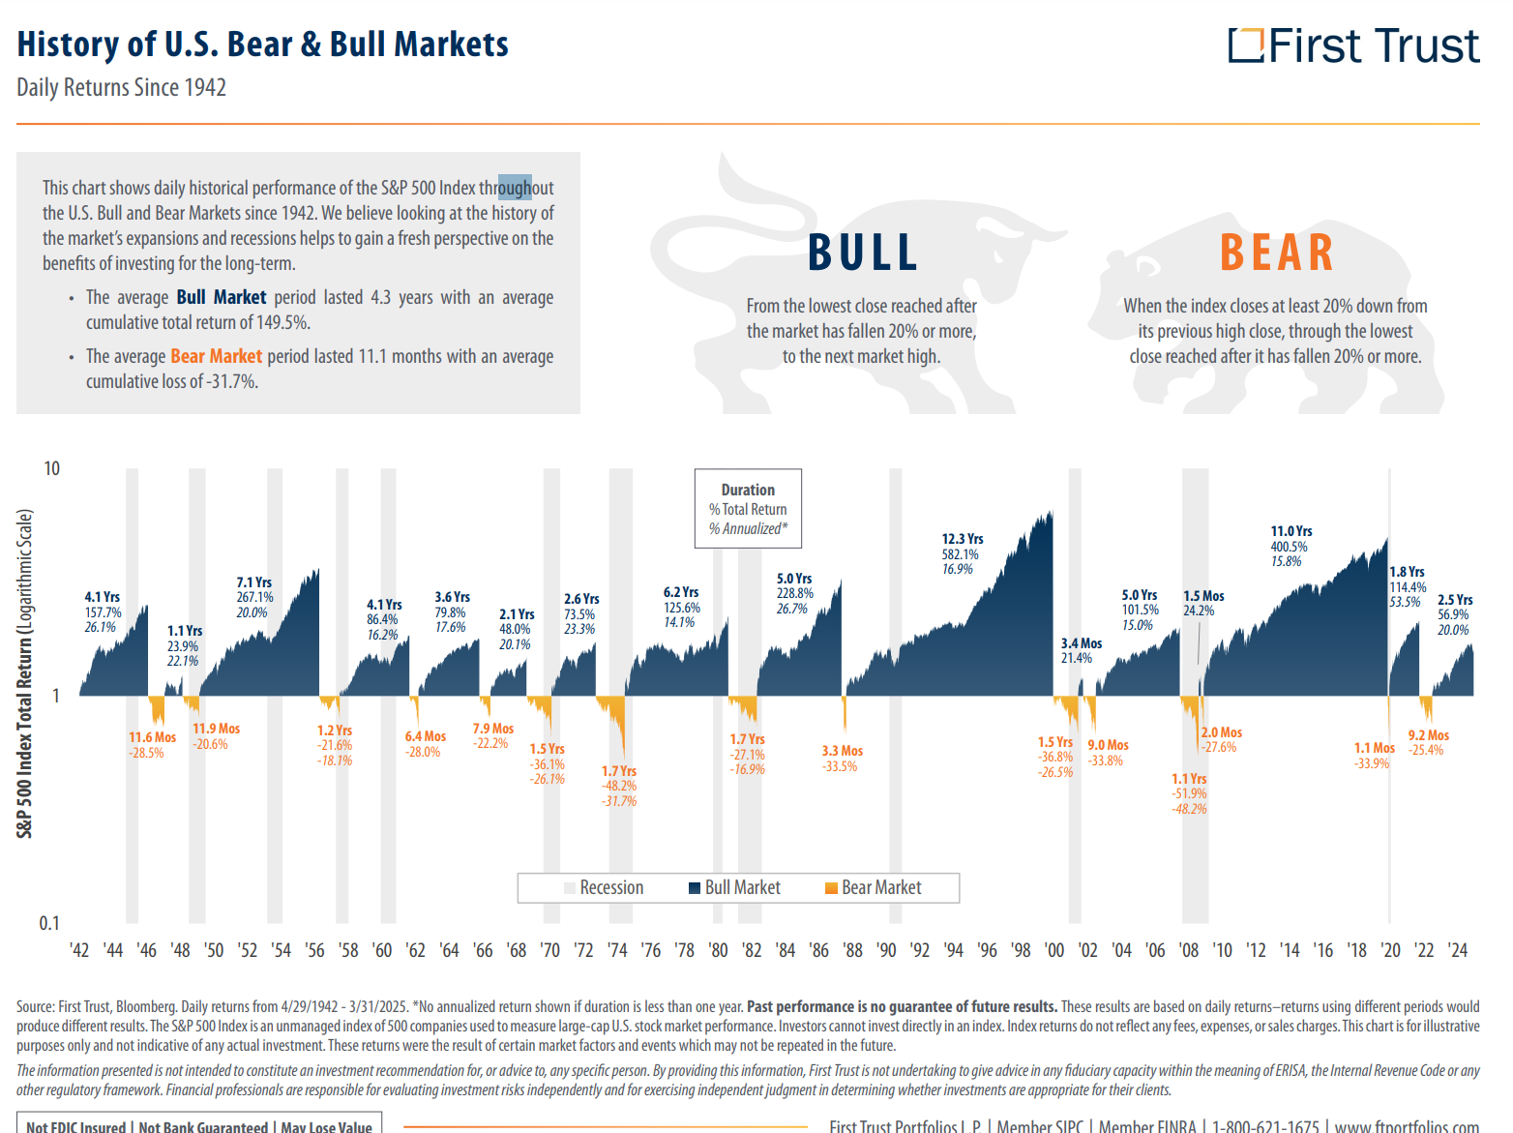
Table of Contents

Project Overview
Project Goals
Purpose
Project Focus
Specific Goals
Expected Outcomes
Project Description
Project Objective and Scope
Data Description
Exploratory Data Analysis
Data Preparation and Cleaning
Model Training
Model Evaluation
User-Interface Integration
Capstone Complexity
Software
Project Completion Plan
● Week 1
● Week 2
● Week 3
● Week 4
● Week 5
● Week 6
● Week 7
Presentation Plan
Resources
FRED Data

Project Overview

My ML Project is about the S&P 500 and spotting long term trends in the economy/market. I have always been interested in macroeconomics and markets, so I decided to combine those interests with machine learning. I believe by analyzing historical S&P data and historical macroeconomic data, that profit opportunities beyond just holding the S&P will show up in a ML model. I don’t expect this model to choose the exact top or bottom, but I expect it to perform better than the 10% S&P average.

Because of the human emotions involved in buying and selling, markets are unpredictable and inefficient in the short-term. However, long-term macro fundamentals provide a much more predictable rising and falling tide. Markets go through business cycles, which pull and push human emotions and market prices above or below the theoretical fair value. Market swings may even make sense based on a 6 month forward outlook, but also offer great buy and sell opportunities based on a longer-term horizon. This seems much more easily put into a model than short-term trends and doesn’t require high frequency trading.

Project Goals

Purpose
The purpose of this project is to use ML to predict optimal long-term buy and sell days for the S&P 500. Long-term will be defined as trades held longer than 1 year. The model will use S&P 500 prices, important dates and information about current events of the time like the political leaning of the federal government, other common indicators like the fear and greed index, and macroeconomic data dating back to 1950 as inputs. S&P 500 prices will also be shown to the model as daily, weekly, and monthly..

Project Focus
This project will focus on its goals of using long-term data to predict optimal buy/sell dates for trades lasting longer than one year. Accomplishing this will involve assessing ideal ML model parameters and algorithms. Another focus will be finding ideal variables to use in the ML model. Finally, the project will focus on creating a React webpage to share the findings in a comprehensive and digestible way.

Specific Goals
- Collect historical S&P data from RapidAPI
- Research common economic leading indicators for a comprehensive list of variables. These will be collected through the APIs from the Federal Reserve Bank of St. Louis (fred.stlouisfed.org).
- Collect historical data from RapidAPI pertaining to: important dates and information about current events of the time like the political leaning of the federal government, and other common indicators like the fear and greed index.
- Preprocess all data to be clean and ready for ML model input.
- Choose the best ML algorithms and optimize model parameters and inputs to maximize ideal predictions and insights.
- Build a user-friendly React webpage for visualizing predictions and any additional insights.

Expected Outcomes
- A ML model capable of predicting buy and sell days on a long-term time horizon with a high degree of confidence, resulting in an outperformance of simply holding the S&P 500.
- Detailed reports and insights into long-term trends in markets.
- A user-friendly interface to show all findings to any viewer.

Project Description

Project Objective and Scope

The objective of this project is to create a ML model that inputs historical data from the S&P 500 and other macroeconomic indicators to output ideal long-term buy and sell dates for profit maximization.

The scope of this project is research of key economic indicators, data collection through APIs, data preprocessing for ML model compatibility, model selection, model training, model evaluation, and model deployment through a Flask interface.

Data Description
- S&P Historical Price Action (RapidAPI)
  - Daily candles
  - Weekly candles
  - Monthly candles
- Macroeconomic Data
  - GDP
  - Inflation
  - Unemployment rates
  - Housing data
  - FED interest rates
- Important Dates and Events
  - FED meetings
  - Recession dates
  - Federal government election cycles
  - Geopolitical developments
- Political Context
  - Political leanings of the federal government
  - Presidential political leanings
- Other more technical indicators
  - Fear and Greed Index
  - Simple Moving Averages
  - MACD
  - Bollinger Bands

Exploratory Data Analysis
- Find correlations between inputs and outputs of the model.
- Find any outliers in the data.
- Find any other long-term trends or insights.
- Use visualizations to understand the data.

Data Preparation and Cleaning
- Remove missing values.
- Control for outliers or errors in data.
- Normalize and scale features to make ready for ML modeling.
- Create, combine, or edit features as needed.

Model Training
- Try different regression Neural Network ML algorithms.
- Test ensemble methods.
- Add or remove features to improve performance.
- Try different model parameters.

Model Evaluation
- Use Mean Absolute Error to evaluate the model’s accuracy.
- Use cross validation to test performance and underfitting or overfitting.

User-Interface Integration
- Build a Flask based dashboard.
- Use coloring to identify important zones and the model’s confidence.
- Include any other insights gained from the model as additional details.

Capstone Complexity
This is a challenging project that fits a Master level capstone project. Financial markets and macroeconomics are big topics and are well studied. I have tried to limit the scope of the project by testing my hypothesis on the most standard market measurement of the US economy, the S&P 500. Pulling from multiple data sources, cleaning the features, optimizing the parameters and model selection should be challenging. I’m excited to get more into it to test my hypothesis that broader market trends can be predicted to maximize profit beyond buying and holding.

Software
- Python: all coding and data gathering will be done in Python.
- Pandas/Numpy: data manipulation and basic analysis
- Scikit learn/Tensorflow: neural networks
- Flask: web application development
- Matplotlib/Seaborn: data visualization
- Request/json: API access

Project Completion Plan

Week 1
- Choose a project
- Decide on a rough plan
- Learn about APIs

Week 2
- Formalize the plan and submit the project proposal.
- Source and collect S&P 500 data.

Week 3
- Research and finalize features to get as inputs.
- Use API to get all data from RapidAPI and the FRED website
- Start cleaning the data

Week 4
- Clean the data
- Preprocess data to be compatible with ML modeling
- Start testing ML algorithms

Week 5
- Try different ML algorithms and ensembles
- Model training
- Parameter tuning and start validation

Week 6
- ML model validation
- Evaluate model performance
- Finalize model optimizations
- Start React webpage

Week 7
- React webpage finalization
- Refine user interface to interact with data and visualizations
- Presentation Video
- Submission
- Email mentor

Presentation Plan
I will do my recording through OBS Studio. I plan to review the information provided in this proposal to give some background information to the viewer. Then I will talk through the process and code that I ended up going through to get to my findings. This will involve going over the Jupyter Notebook where I did my work. Finally I will go over all my findings and demonstrate the React webpage.

Resources
RapidAPI
Federal Reserve Economic Data (FRED)
Python documentation
Prior courses materials for refreshing
ML class textbook
Google

FRED Data (seen in README)

Hurley-DTSC691
Data Sources
1. All Employees, Total Nonfarm (PAYEMS)
URL: PAYEMS
Source: U.S. Bureau of Labor Statistics
Release: Employment Situation
Units: Thousands of Persons, Seasonally Adjusted
Frequency: Monthly
Notes:
Commonly known as Total Nonfarm Payroll, this measure excludes proprietors, private household employees, unpaid volunteers,
farm employees, and the unincorporated self-employed.
Provides insights into the current economic situation by representing the number of jobs added or lost in the economy.
Adjusted for seasonal effects to show non-seasonal changes.
2. Industrial Production: Total Index (INDPRO)
URL: INDPRO
Source: Board of Governors of the Federal Reserve System (US)
Release: G.17 Industrial Production and Capacity Utilization
Units: Index 2017=100, Seasonally Adjusted
Frequency: Monthly
Notes:
Measures the real output of manufacturing, mining, and utilities.
Provides insights into structural developments in the economy.
3. Employment Level (CE16OV)
URL: CE16OV
Source: U.S. Bureau of Labor Statistics
Release: Employment Situation
Units: Thousands of Persons, Seasonally Adjusted
Frequency: Monthly
Notes:
Tracks the employment level of the civilian noninstitutional population.
4. Unemployment Rate (UNRATE)
URL: UNRATE
Source: U.S. Bureau of Labor Statistics
Release: Employment Situation
Units: Percent, Seasonally Adjusted
Frequency: Monthly
Notes:
Represents the number of unemployed as a percentage of the labor force.
Defined as the U-3 measure of labor underutilization.
5. Gross Domestic Product (GDP)
URL: GDP
Source: U.S. Bureau of Economic Analysis
Release: Gross Domestic Product
Units: Billions of Dollars, Seasonally Adjusted Annual Rate
Frequency: Quarterly
Notes:
Measures the market value of goods and services produced by labor and property in the U.S.
6. Gross Domestic Product (A191RP1Q027SBEA)
URL: A191RP1Q027SBEA
Source: U.S. Bureau of Economic Analysis
Release: Gross Domestic Product
Units: Percent Change from Preceding Period, Seasonally Adjusted Annual Rate
Frequency: Quarterly
Notes:
Tracks percentage changes in GDP over time.
7. Consumer Price Index (CPIAUCSL)
URL: CPIAUCSL
Source: U.S. Bureau of Labor Statistics
Release: Consumer Price Index
Units: Index 1982-1984=100, Seasonally Adjusted
Frequency: Monthly
Notes:
Measures the average change in prices paid by urban consumers for goods and services.
Commonly used to track inflation.
8. Sahm Rule Recession Indicator (SAHMCURRENT)
URL: SAHMCURRENT
Source: Sahm, Claudia
Release: Sahm Rule Recession Indicator
Units: Percentage Points, Seasonally Adjusted
Frequency: Monthly
Notes:
Signals the start of a recession when the unemployment rate rises by 0.50 percentage points or more relative to the previous 12
months.
9. Composite Leading Indicators (LORSGPORUSQ659S)
URL: LORSGPORUSQ659S
Source: Organization for Economic Co-operation and Development
Release: Main Economic Indicators
Units: Growth rate same period previous year, Seasonally Adjusted
Frequency: Quarterly
Notes:
Tracks leading indicators for economic activity.
10. Farm Business Land Value (BOGZ1FL135010005Q)
URL: BOGZ1FL135010005Q
Source: Board of Governors of the Federal Reserve System (US)
Release: Z.1 Financial Accounts of the United States
Units: Millions of Dollars, Not Seasonally Adjusted
Frequency: Quarterly
Notes:
Tracks the market value of land in farm businesses.
11. University of Michigan: Consumer Sentiment (UMCSENT)
URL: UMCSENT
Source: University of Michigan
Release: Surveys of Consumers
Units: Index 1966:Q1=100, Not Seasonally Adjusted
Frequency: Monthly
Notes:Measures consumer sentiment based on surveys.
12. Real Personal Income Excluding Current Transfer Receipts (W875RX1)
URL: W875RX1
Source: U.S. Bureau of Economic Analysis
Release: Personal Income and Outlays
Units: Billions of Chained 2017 Dollars, Seasonally Adjusted Annual Rate
Frequency: Monthly
Notes:
Tracks real personal income excluding transfer receipts.
13. Velocity of M1 Money Stock (M1V)
URL: M1V
Source: Federal Reserve Bank of St. Louis
Release: Money Velocity
Units: Ratio, Seasonally Adjusted
Frequency: Quarterly
Notes:
Measures the frequency at which one unit of currency is used to purchase domestically-produced goods and services.
14. Velocity of M2 Money Stock (M2V)
URL: M2V
Source: Federal Reserve Bank of St. Louis
Release: Money Velocity
Units: Ratio, Seasonally Adjusted
Frequency: Quarterly
Notes:
Tracks the velocity of M2 money stock, providing insights into economic activity.
15. Federal Funds Effective Rate (DFF)
URL: DFF
Source: Board of Governors of the Federal Reserve System (US)
Release: H.15 Selected Interest Rates
Units: Percent, Not Seasonally Adjusted
Frequency: Daily
Notes:
Represents the interest rate at which depository institutions trade federal funds with each other overnight.
16. Interest Rates, Discount Rate for United States (INTDSRUSM193N)
URL: INTDSRUSM193N
Source: International Monetary Fund
Release: International Financial Statistics
Units: Percent per Annum, Not Seasonally Adjusted
Frequency: Monthly
Notes:
Tracks the discount rate for the United States.

